FEAR - DESTRUCTION - POWER ARMOR SMASH

1 Introduction 2
2 Objects involved 2
2.1 The Cars 2
2.2 Making a Blocker 3
2.3 The Impulse 4
2.4 The Sound and The Fury 4
2.5 The CommandObject 4
2.6 The NavMesh, The NavLink and the Trigger 5

Introduction

There are many different types of AINavMeshLinks and depending on how creative you can get, you can use many of them for destruction events that the AI initiates. In this tutorial we’ll cover using an AINavMeshLinkDiveThru to encourage a Power Armor enemy to crush a car and flip it aside. There is an example world to accompany this, and you might want to have it open while you read through this explanation. The example world for this tutorial is called, Destruction_PowerArmorSmash_01. Load up this level, run it, and then step up onto the checkered platform in front of you to watch the event.

Like the Wall Break Events, we start the scene with a perfect, pristine version of a car and once the event is triggered, we hide the perfect car and unhide a broken car that has been placed in the same spot. For the example map that goes along with this tutorial, the objects that I will cover are all located in the WORK/CAR folder in the node tree.

Objects involved

The Cars

You will have to set up the objects that the AINavMeshLink will interact with before you lay down the NavMesh and the Links. We have 2 different WorldModels that represent our car:

- CarGood is a Worldmodel that represents the perfect version of our car before it is crushed by the Power Armor.
  - CarGood contains the BSP brushes that make up the car
  - PhysicsShape is set to Hull.
  - MassKg is set to 90 and DensityG is set to 9.1.
  - This Worldmodel should start out with StartHidden set to False and RigidBody set to False.

The mass and density are not overly important in themselves (although they do seem to make a difference in what physics items are allowed to pass through), but setting a physics shape is important to keep other physics objects from getting pushed or knocked through the body of the car. All WorldModels have this problem unless they have their PhysicsShape defined.

- CarCrush is a Worldmodel that represents the crushed version of our car.
  - It contains the BDP brushes that make up the car.
  - BoxPhysics is set to False and the PhysicsShape is set to None because we are using several PhysicsShapeOBBs as our physics shape for the broken car.
  - This Worldmodel starts out with StartHidden set to True and RigidBody set to False.

In this case we went with several PhysicsShapeOBBs (set in a pattern that matched the general shape of the car) instead of using Hull. Hull could have been used, but where this car was being used was in an area where the frame rates were already on the borderline of bad, so every extra frame we could get was important. And even several PhysicsShapeOBBs are cheaper than a setting of Hull. A total of 10 PhysicsShapeOBBs were used.

Making a Blocker

We want the car to appear like it was flipped or kicked out of the way when the Power Armor smashes through it. Unfortunately an impulse fired on a physical object will not necessarily cause any spin or flips on the object. You have to get heavy-handed and force it. One way to do this is to set up a “blocker” that the car will slam into from the force of the impulse, and depending on where the impact point is and how forceful the impulse is, the car will flip at the impact point. Depending on what you want from your flip or spin, you might have to do a lot of experimentation with the placing and sizing of the blocker. In this case, we want the car to spin around and outward from where the Power Armor will smash it, so after experimentation, we discovered that the sweet spot for the blocker placement was at the car’s left rear wheel.

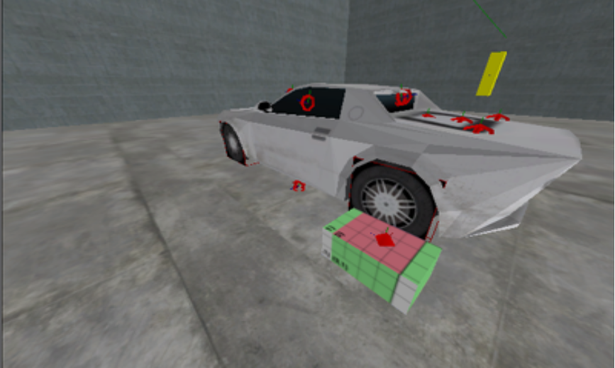

The “blocker” is simply a WorldModel that has a Physics Collision set up on it. Set the following flags on the blocker:
Visible: False
Solid: False
Rayhit: True
CastShadow: False
ShadowLOD: Never
BoxPhysics: True
RigidBody: False
StartHidden: False
PhysicsShape: OBB
MassKg: 90
DensityG: 9.1

You would not want the player to ever actually see the blocker and you would also not want the player to run into this “invisible” blocker if they happen to run up along side the car, so the blocker will start out non-visible and non-solid and will later be turned Solid right before the car gets goes RigidBody True and gets slammed with the impulse.

The Impulse

The impulse was a PhysicsImpulseDirectional and it was placed on the right “passenger” side of the car.

- Its Rotation was turned to face the car as this was the side in which the Power Armor would be smashing into it from.
- The Target of the PhysicsImpulseDirectional was the crushed version of the car, CarCrush.
- The ImpulseForce was set to 150000. The ImpulseForce is another value you will have to play around with to hit that “sweet-spot” taking into consideration the total weight of the car and exactly how far and wildly you want the car to flip or spin. Obviously really high numbers will give crazier results.

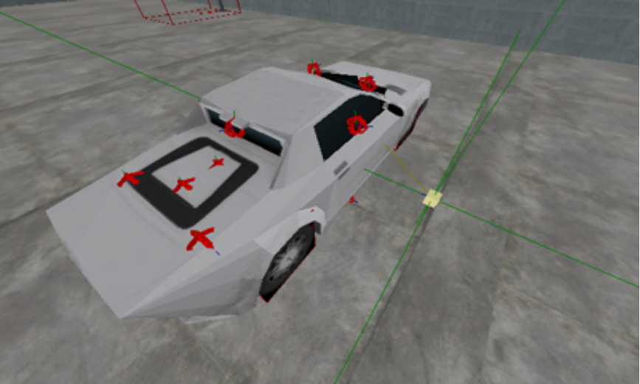

The Sound and The Fury

You will also want to set up SpecialFX objects and SoundFX objects for the smashing of the car. Since I’ve already covered these in the previous tutorials, I will not cover them again here. If you want to know the SpecialFX and sounds I used, just look at the objects in the map world that accompanies this tutorial.

The CommandObject

Again, it is the CommandObject that controls the show. A total of 5 timelines were used in this CommandObject.

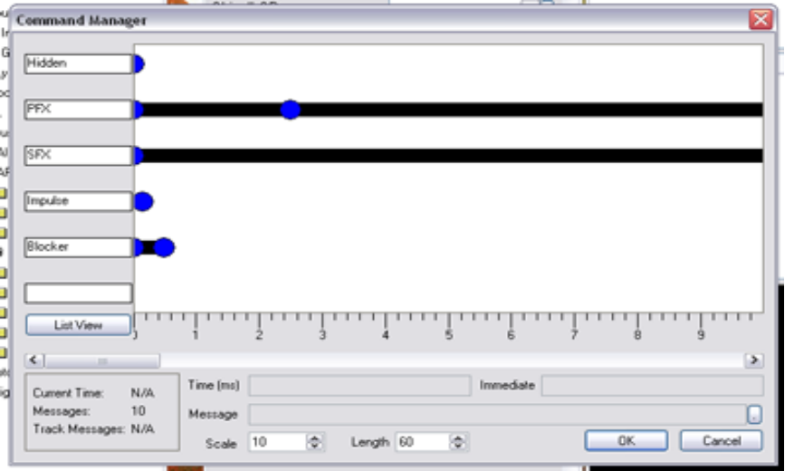

One timeline controlled the hiding and un-hiding of the CarGood and CarCrush. Two other timelines controlled the setting off of the SpecialFx and the Sounds. Another one controlled the impulse. And yet another controlled the “blocker”. The “blocker” was handled in the following way:
- At 0 seconds the blocker was turned Solid with the following command:
msg blocker (solid 1);
- At 150 milliseconds the CarCrush was turned physical and the impulse was set off:
msg CarCrush (rigidbody 1);
msg PID on;
- At 500 milliseconds the blocker was removed from the world:
msg blocker remove;

The NavMesh, The NavLink and the Trigger

To enable the AI to set all of this destruction into motion, an AINavMeshLink and its SmartObject were the main components used. In this case, I only wanted Power Armors to be able to use the Link, so I had to set up a special self-contained AINavMesh (I’ll not cover this here as it is covered in other tutorials) and make the Link a child of the special AINavMesh. As with the AINavMesh, the setup of AINavMeshLinks are covered in other tutorials and will not be covered here except how to tie them into our destruction event of the Power Armor smashing through the car.

- The Link used for this event is an AINavMeshLinkDiveThru with a SmartObject of PAXP_Crush and an Object of Trigg. The Object field of the Link is the name of the object that the Link will activate when the AI crosses.
- Trigg is a Trigger that has its NumberOfActivations set to 1. When activated by the above Link it will start the CommandObject that contains all the scripting to cause the car to appear to get crushed and kicked out of the way of the Power Armor.

If you’ve set everything up correctly, an AI crossing the Link will set off the chain of events you have specified. In this way, AINavMeshLinks could be used for any number of cool things that an AI could do.

You are encouraged to rip apart the example tutorial worlds to see how they work. Also, dive into all the destructible prefabs that were made for Extraction Point.

